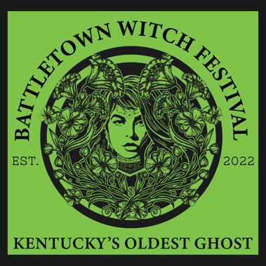 Event Deck: Battletown Witch Festival

1. Event Overview
Name: Battletown Witch Festival
Location: Meade County, Kentucky
Date: October 26, 2024
Duration: 8 hours
Theme: Celebrating local folklore and supernatural history

2. Festival Highlights
Main Attractions:
- Event Speakers: Experience spine-chilling thrills with our expert speakers and entertainers.
- Mystical Market: Shop for unique, witch-themed crafts, potions, and memorabilia.
- Live Performances: Enjoy eerie dance performances and storytelling sessions.
- Podcasting Suite: A professional recording suite for our friends in the paranormal podcasting world to come to the festival and record live during the event.
- Kids Area: Bounce houses, and activities for the little ones to keep them entertained and out of trouble all day.
Special Events:
- Costume Contest: Show off your best witch or supernatural-themed attire.
- Witch Dance: A midnight dance under the moonlight with live music and ethereal decorations.
- Paranormal Investigators: Professional paranormal teams come in and sharing their expertise on the subject of ghosts and hauntings.
- Food and Beverage: Local food truck gathering with a diverse collection of cuisines.

3. Sponsorship Opportunities
Title Sponsorship:
- Premier visibility in all marketing materials
- Naming rights to the festival (e.g., "Battletown Witch Festival presented by [Sponsor]")
Official Beverage Sponsor:
- Exclusive rights to provide water and other non-alcoholic drinks
- Prominent branding at all beverage stations
Event Area Sponsorship:
- Sponsorship of specific areas like the Main Stage, Kids Area, or Vendor Village
- Branding opportunities in designated areas
Promotional Partnerships:
- Co-branded merchandise, social media contests, and giveaways
Sampling and Activation:
- Booths or activation zones for product sampling and brand engagement
Custom Sponsorship:
- Tailored sponsorship packages to meet specific marketing goals

4. Marketing and Promotion
Target Audience:
- Six-State pull in 2023 and full expansion into the South East by 2025
- Tourists and visitors interested in supernatural and folklore
- Families, young adults, and enthusiasts of spooky themes
Marketing Channels:
- Social Media: Facebook, Instagram, YouTube
- Local Newspapers and Magazines
- Collaborations with podcasts, influencers and bloggers
Promotional Activities:
- Hospitality packages for overnight camp out guests
- Social media contests and giveaways
- Press releases and media coverage
- Community engagement events leading up to the festival

5. Logistics and Operations
Venue Details:
- YMCA Camp Piomingo, 1950 Otter Creek Road, Brandenburg, KY 40108
- Offsite parking for attendees with shuttle service through Jefferson Tours
- Handicap Accessibility
Safety Measures:
- Staff on-site 24/7
- Meade County EMS on-call
- Working directly with Park Ranger, Brandenburg City Police, and MCSO
Volunteer and Staffing:
- Meade County Tourism - Volunteer recruitment and management
- Annie Hamilton Emond – Day of MC and program management
- Malina Thomas – Overnight and hospitality management
- Emond and Thomas – Day of dual coordination

6. Contact Information
Event Coordinator: Annie Hamilton Emond
Email: director@meadekychamber.org
Phone: 270-422-3626
Website: https://battletownwitch.com/

7. Conclusion
The Battletown Witch Festival is set to be a thrilling and unforgettable event, celebrating the eerie and enchanting history of Meade County. We look forward to collaborating with sponsors and partners to make this festival a magical experience for all attendees.

